Cryptogram solver report

# Carolina kimbrough & zoey abrigo

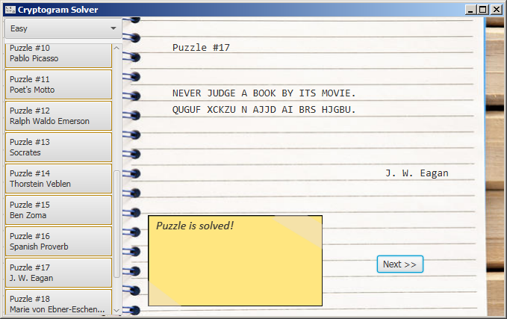

## aBOUT

Using logic, we aim to solve cryptogram puzzles.

## method

The language employed here is Java. In addition, this program utilizes a GUI interface, specifically utilizing JavaFX. The program is organized in a MVC format, model-view-controller, with **CryptoMain.fxml** as our view, **CryptoMainController.java** as our controller and the following classes in as our model:

* + **Dictionary.java** – Intended to house data and characteristics of words, contains an actual dictionary of the words collected from our quotes. This is an attempt to simulate knowledge a human being would have.
  + **PuzzleBox.java** – Contains the actual set of puzzles. Most importantly, contains the method to make puzzles out of the quotes.
  + **Quote.java** – The most busy part of the program. Originally it housed just the quote and its cryptotext equivalent but over time has developed to contain multitudes of data for each quote. It contains easy, medium and hard versions of the quote, hashmaps for character frequency, and keys that convert a character to its crypto version and back. There’s also information about the quote’s author, its length and it also has arraylists of the words in the puzzle along with its crypto equivalent and of the easy, medium and hard versions of the puzzle.
  + **Solver.java** – This part of the program does the problem-solving. An instance is generated for each puzzle and for each difficulty. This has info a human puzzle-solver might have such as a dictionary, the current quote, and various kinds of info about the quote puzzle including its difficulty and the characters found as well as a running solution in String form.
  + **Word.java** – Contains information on each word

### Coming up With the puzzles

Using a .csv file of quotes from this website: <https://litemind.com/favorite-quotes/>, python was used to parse the quotes and narrow down our sample to around 40 puzzles. Of the ~40 puzzles, only 20 are displayed in the actual program, however, all were actually utilized under the covers.